On Thursday December 11th is our Christmas fair. We will be raising funds for Friends of Tanfield Lea Community Primary School. In school we have made various Frozen-themed goodies for us to sell…..
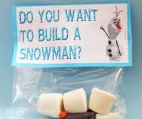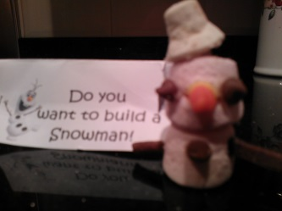
“Do you want to build a snowman” kits (£1.00) Frozen sleighs” (£1.50)
During school time on the day of the school fair we will be offering face painting for pre-school and reception children (Tuesday 9th December for the Bumblebees).
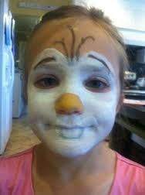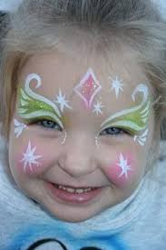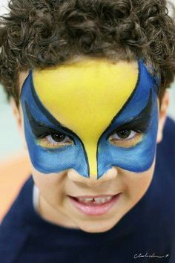

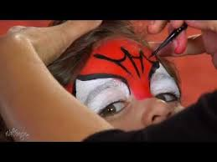

There will also be an exciting competition.

We look forward to seeing you there!

